Hawk’s Head Public House
Private Dinner Events Information

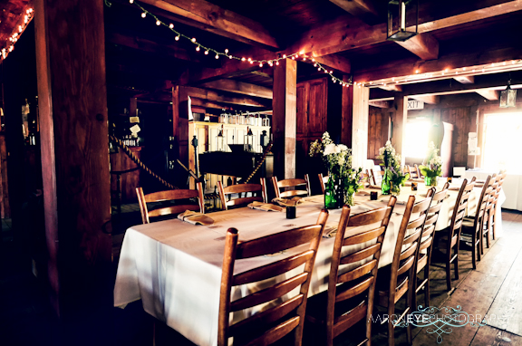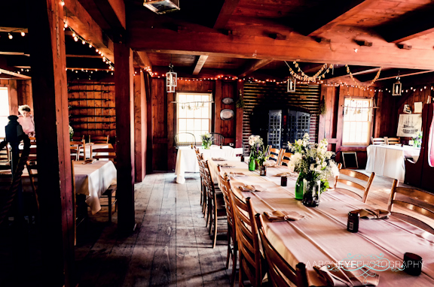

- Groups may book a special dinner event after normal business hours in the colonial tavern.
- Service staff is dressed in black and white or 1770s attire (guest’s choice). Tavern is closed to the public.
- Prices include seating for 90 people maximum, for three hours, place settings, and buffet style meals.
- Illumination is by candle light for dinner events. Additional complimentary lighting is available by request.
- All banquet dinners include bottomless lemonade, iced tea, water, and coffee.
- Alcoholic beverages and live music are available at an additional cost.
- One special activity - tomahawk throwing, archery, hayrides, or candle dipping - is included!

$34.95 per adult, $27.95 per child ages 3-12 (includes sales tax and service charge) Minimum $2,000

Appetizers
(select one)
Stuffed Mushrooms
Greek Meatballs
Toasted Bread with Cheese Spread
Fresh Fruit Trays (seasonal)
Spinach & Feta Triangles
in Filo Dough
Bread
(select one)

Sally Lunn Bread
Fresh Ground Wheat Bread
Dinner Rolls
Corn Bread
Buttermilk Biscuit
Soup or Salad
(select one)
Corn Chowder
Pumpkin Soup (seasonal)
Lentil or Vegetable Soup
Romaine Salad with Buttermilk Ranch
European Salad with Balsamic Vin.

Entrées
(select one)

English Roast Beef
Lemon Herb Chicken
Cider Baked Ham
Chicken Pot Pie
Vegetable Pot Pie

Dessert
(select one)

Apple Crisp
Apple Dumplings (add $4)
Peach-Cherry Cobbler
Maple Pecan Bread Pudding
Side Dishes
(select two)
Baked Potato
Red Herb Potatoes
Homemade Mashed Potatoes
Candied Carrots
Buttered Green Beans
Gourmet Macaroni and Cheese
Wild Rice

